
2026
Augmented Reality Navigation System
Graduation Project Report
Future Academy - Higher Future Institute for Specialized Technological Studies
School of Computer Science
Project report submitted to the Future Academy
for the degree of Bachelor of Computer Science
May 2026

Team Members:
- Mazen Ahmed Mohamed Abdelhamed
- Ziad Mohamed Abdelaziz Abdelhamid
- Ziad Alsspaie Ali Alssepaie
- Ahmed Mohamed Ibrahim
- Abdallah Elsayed Rashad Elsayed
Project Supervisor:DR/Mostafa Ebrahim


[Optional Project Logo]
[Optional Students pictures]
Acknowledgement

We would like to express our deepest gratitude to all those who contributed to the successful
completion of this graduation project.
First and foremost, our sincere thanks go to our esteemed supervisor, Dr. Mostafa Ebrahim , for his invaluable guidance, continuous support, and encouragement throughout every phase of this
project. His expertise, patience, and insightful feedback played a crucial role in shaping our work
and pushing us to strive for excellence.
We are also sincerely thankful to our families and friends for their unwavering belief in us. Their
emotional support, motivation, and understanding during the most challenging moments of our
academic journey have been an invaluable source of strength and resilience.
Lastly, we extend our appreciation to everyone who, directly or indirectly, contributed to the
success of this project. Your help, encouragement, and belief in our vision made this achievement
possible.
We are truly grateful to each and every one of you.


Abstract

Navigation systems have become essential in daily life; however, indoor environments present challenges for traditional GPS-based navigation, such as signal loss and inaccuracy. This project presents the design and implementation of an Indoor Augmented Reality Navigation System, which overlays virtual navigation instructions directly onto the real-world indoor environment.
The system integrates augmented reality technology with real-time indoor positioning methods (e.g., Wi-Fi, Bluetooth beacons, or RSSI-based location tracking) to provide accurate, interactive guidance. Users can follow directional arrows, route indicators, and relevant information displayed directly in their field of view through a smartphone or AR device.
This solution improves indoor navigation efficiency, reduces user distraction, and provides a more immersive experience compared to traditional map-based systems. Experimental testing in various indoor scenarios demonstrates the system's usability, accuracy, and reliability.

Table of Contents
Chapter1 Introduction and Background 1
1.1 Introduction 2
1.2 Problem definition 2
1.3 What is the importance of this problem? 2
1.4 What are the current solutions? 2
1.5 How will your solution solve the problem? What is new? 2
1.6 Scope: 3
SummaryChapter 2 Analysis and Design 4
2.1 Introduction 6
2.2 User and System Requirements 6
2.2.1 Functional requirements 6
2.2.2 Non – functional requirements 6
2.3 Stack holders 6
2.4 System Design 6
2.4.1 Block Diagram & Data Flow Diagram 6
2.4.2 Use Cases 6
2.4.3 Class Diagram 6
2.4.4 Design Patterns 6
2.4.5 Sequence Diagrams 6
2.4.6 Database Design 6
2.5 Used Technologies and tools 7
2.6 Summary 7
Chapter 3 Deliverables and Evaluation 8
3.1 Introduction 9
3.2 User Manual 9
3.4 Testing 9
3.5 Evaluation (User experiment) 9
Summary 9
Chapter 4 Discussion and Conclusion 9
4.1 Introduction 10
4.2 Main Findings 10
4.3 Why is this project important 10
4.4 Practical Implementations 10
4.5 Limitations 10
4.6 Future Recommendation 10
4.7 Conclusion Summary 11
References 12

Table of Figures
Figure 1: example for adding photos 2
Figure 1.2 : ………………………………………………………………………………….
Figure 2: software development life cycle 4
Figure 2.1 : ………………………………………………………………………………….
Figure 3 10
Figure 3.1 : ………………………………………………………………………………….

Chapter1
Introduction and Background
Main points
Introduction
Problem definition
What is the importance of this problem?
What are the current solutions?
How will your solution solve the problem? What is new?
Project Description
Scope
Methodology (Proposed Approach)
Deliverables
Summary

Introduction
Navigation has become an essential part of everyday life, helping people move efficiently in both outdoor and indoor environments. While outdoor navigation is commonly supported by GPS-based systems, indoor navigation presents unique challenges due to signal loss, multipath interference, and physical obstacles. Large indoor spaces such as shopping malls, airports, hospitals, and university campuses often confuse users and make traditional navigation methods less effective.
This project aims to design and implement an Indoor Augmented Reality Navigation System that enhances user experience by overlaying digital navigation instructions directly onto the real-world environment. By combining augmented reality technology with indoor positioning methods, the system provides intuitive, interactive, and accurate guidance, reducing confusion and improving efficiency in complex indoor spaces.
Problem definition

Indoor navigation is a challenging task, as GPS-based systems are often unreliable inside buildings due to walls, obstacles, and signal interference. Traditional methods, such as printed maps or 2D mobile apps, require users to frequently switch attention between the map and the environment, causing confusion and inefficiency.
Emerging technologies like Augmented Reality (AR) and indoor positioning systems (Wi-Fi, Bluetooth ) can provide real-time, interactive guidance by overlaying directions directly onto the user’s view.
This project aims to design an Indoor AR Navigation System that offers accurate, user-friendly navigation in complex indoor environments.

What is the importance of this problem?

Indoor navigation is a critical challenge with wide-ranging implications for daily life, safety, and efficiency. Large and complex indoor environments, such as airports, shopping malls, hospitals, universities, and corporate buildings, often confuse users due to lack of intuitive guidance. The inability to navigate efficiently can lead to wasted time, missed appointments, and increased stress for visitors.
From a technological perspective, the problem highlights limitations of conventional navigation systems that rely on GPS or static maps, which cannot provide accurate positioning indoors. Addressing this problem encourages the development of innovative solutions using emerging technologies such as Augmented Reality (AR) and indoor positioning systems, contributing to the advancement of human-computer interaction and smart environment applications.
The problem also has significant implications for safety and accessibility. In emergencies, such as fires or evacuations, an effective indoor navigation system can guide people to exits quickly, potentially saving lives. Moreover, providing accurate and interactive guidance can support individuals with disabilities, making indoor spaces more accessible and inclusive.
Solving this problem has commercial and practical importance as well. Businesses can improve customer experience in retail environments, airports can enhance passenger flow, and universities can help students and visitors navigate campus buildings efficiently. By developing an Indoor AR Navigation System, this project addresses both societal needs and technological gaps, providing a practical solution with tangible benefits for users, organizations, and the broader research community.

What are the current solutions?
At the beginning of the project, we tested Bluetooth Low Energy (BLE) using RSSI (Received Signal Strength Indicator) with beacon devices to measure distance based on signal strength
During testing, we found that the effective range of each beacon was around 5 meters only. This short range meant that we would need a large number of beacon devices to cover the required area.
Using many beacons would increase the overall cost and make the system more complex to install and maintain. In addition, the RSSI readings were affected by walls, obstacles, and signal interference, which reduced the accuracy.
Because of these limitations, especially the short range and higher cost, we decided that this solution was not the most suitable for our project and started looking for better alternatives.

How will your solution solve the problem? What is new?

In the second phase, we used Wi-Fi instead of Bluetooth beacons because Wi-Fi has a larger coverage range, which makes it more suitable for large buildings.
Although Wi-Fi is less accurate than beacons at short distances, this was not a problem since our application is designed for very large indoor areas.
First, we divided the building into several reference points. At each point, we collected the RSSI values from the available Wi-Fi access points and stored them in the database.
When the user wants to know their location, the application reads the current RSSI values and compares them with the stored data. Based on the closest match, the system determines the user’s position.
This method follows the same fingerprinting concept used before, but with Wi-Fi instead of beacons.

Introduction

Introduction

Problem definition

What is the importance of this problem?

What are the current solutions?

How will your solution solve the problem? What is new?

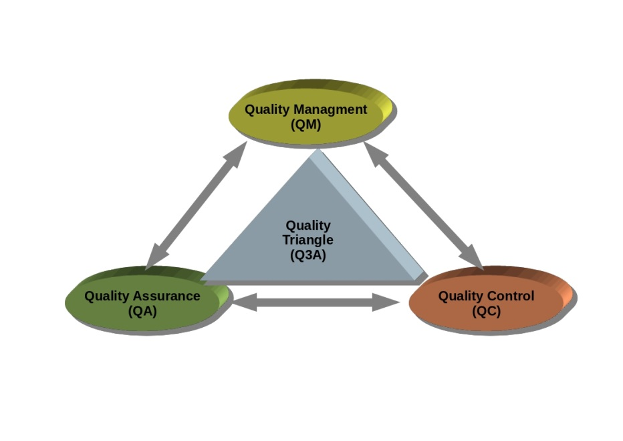
Figure 1: example for adding photos

Project Description

Scope:
Methodology (Proposed Approach)
Header 1 | Header 2
Table 1 : example for adding a table

Deliverables

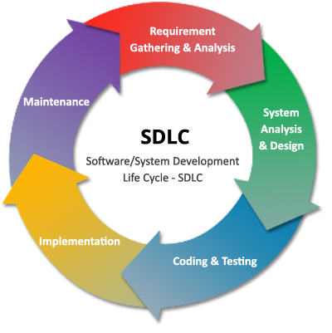
Figure 2: software development life cycle

Summary
Chapter 2
Analysis and Design
Main points
- [give a brief abstract of your chapter here]

Introduction

User and System Requirements

Functional requirements

Non – functional requirements

Stack holders

System Design

Block Diagram

Use Cases

Class Diagram

Design Patterns

Sequence Diagrams

Database Design

Used Technologies and tools

Summary

Chapter 3
Deliverables and Evaluation
Main points
- [give a brief abstract of your chapter here]

Introduction

User Manual

Testing

Evaluation (User experiment)

Summary

Chapter 4
Discussion and Conclusion
Main points
- [give a brief abstract of your chapter here]

Introduction
Lorem ipsum dolor sit amet, consectetuer adipiscing elit.

Figure 3

Main Findings

Why is this project important

Practical Implementations

Limitations

Future Recommendation

Conclusion Summary

References

